What does Neighbourhood and Embedding mean in t-SNE?

**Neighbourhood:** Neighbourhood of any point(x1) are points which are gemoterically close to x1.

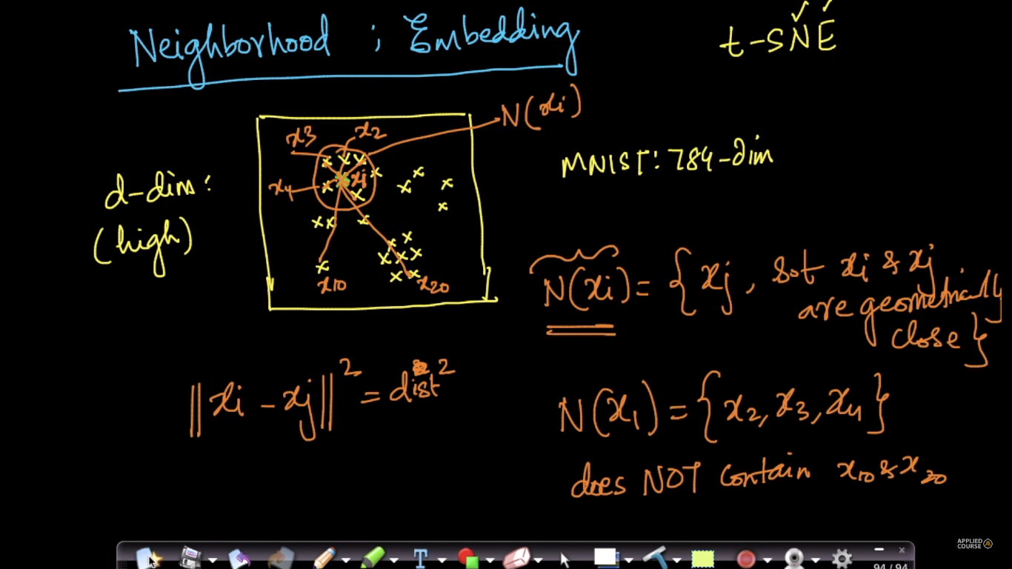

**Embedding:** Embedding means picking elements from d-dimensions and place them in lower dimensions, like in below fig we are placing xi (having d features) from d-dimension to 2-dimesion xi’, having 2 features.

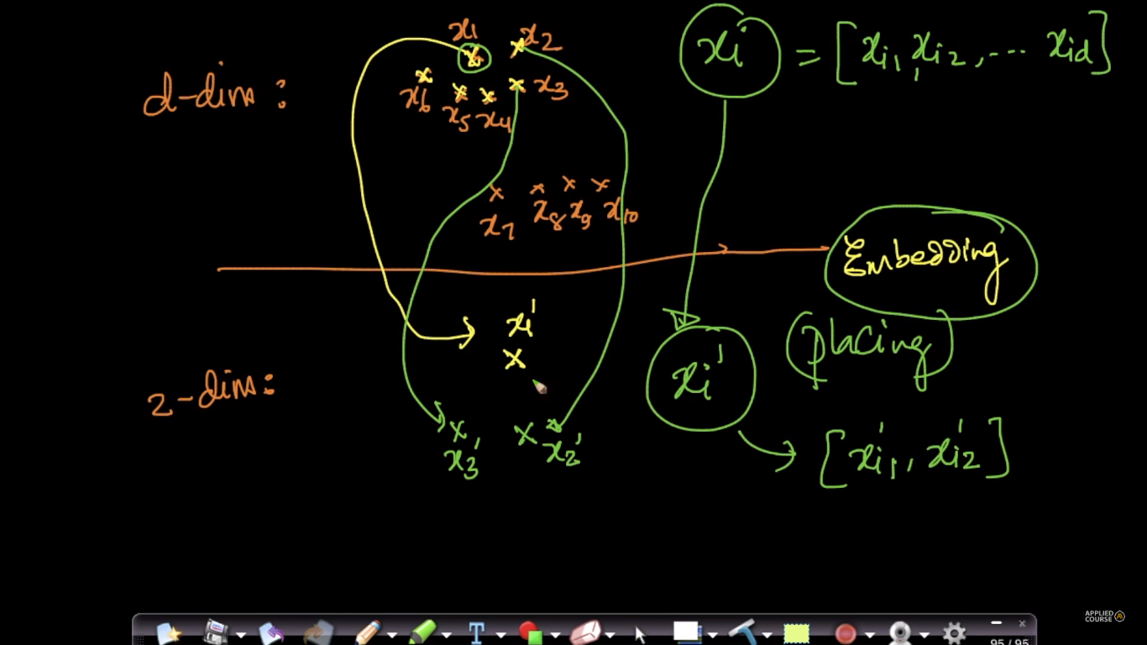

**Comments:**

* what is the minimum distance between xi & xj to determine that they are neighbours?

There is no minimum distance as such as it depends on the data, scale or units in which each feature is represented etc. We typically use k-nearest neighbors to represent a neighborhood around a point. Here again, the appropriate "k" depends a lot on the problem and context.

* What is the Intuition behind the Embedding ? What is the use of collecting points in d-dim and putting them into 2-dim ?

as we now, we human beings can't visualize the data if its more then 3 dimensions, so tsne is one of the technique that helps us visualize the higher dimensions data by embedding them to lower dimensional space,